AI Lab Assignment 13.4
Name: k.uma maheshwari
Batch 44
2303A52430
Task 1: Refactoring Data Transformation:
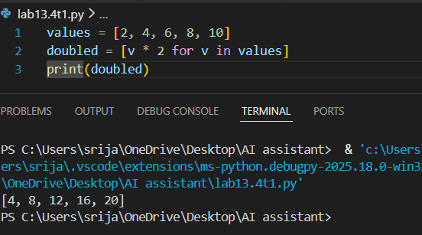

Observation
- The original code used a for loop and append() method to double each value in the list.
- The refactored code uses list comprehension, which is a more Pythonic and concise approach.
- List comprehension reduces the number of lines of code and improves readability.
- The functionality of the program remains the same, and the output is still [4, 8, 12, 16, 20].
- The refactored version is more efficient and easier to maintain compared to the legacy loop-based code.
Task 2: Improving Text Processing Code Readability
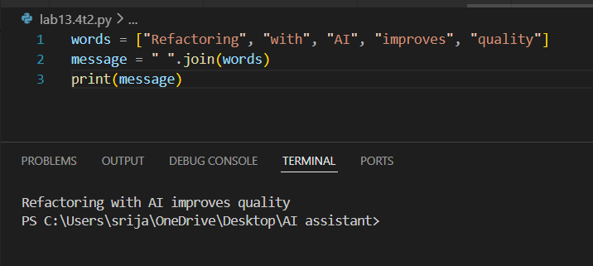
Observation
- The legacy code used string concatenation inside a loop, which is less efficient.
- The refactored code uses join(), which is the recommended Pythonic way to combine strings.
- join() improves readability, performance, and reduces code length.
- The final output remains the same as the original program.
Task 3: Safer Access to Configuration Data
Prompt
Refactor the given Python code to improve safety and readability when accessing dictionary values. The current program checks if a key exists in the dictionary before printing its value. Suggest a more Pythonic approach using safer dictionary access methods such as get(). Ensure that the behavior of the program remains the same when the key is missing, and the output should still display “Default timeout used.”
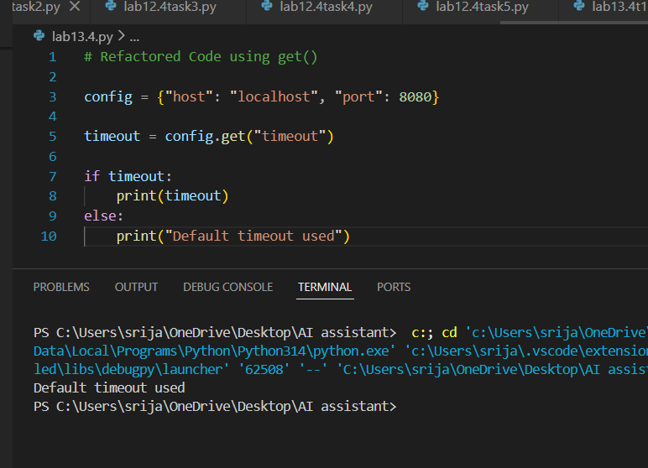

Observation
- The legacy code checks the key using if "timeout" in config before accessing it.
- The refactored code uses config.get("timeout"), which safely retrieves the value.
- If the key does not exist, get() returns None, preventing errors.
- This approach makes the code cleaner, safer, and more Pythonic.
- The program output remains the same when the key is missing.
Task 4: Refactoring Conditional Logic for Scalability
Prompt
Refactor Python code replacing multiple if-elif conditions with dictionary mapping for cleaner scalable operations.
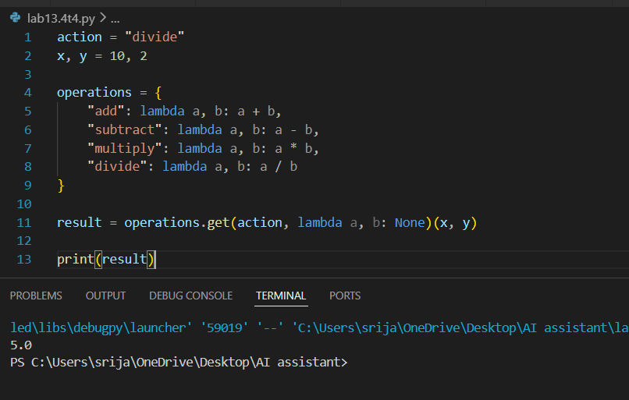

Observation
- The legacy code used multiple if–elif conditions to select operations.
- The refactored code uses a dictionary mapping actions to functions.
- This approach improves scalability, readability, and maintainability.
- New operations can be added easily by adding new entries to the dictionary.
- The output remains 5.0, same as the original program.

Task 5: Simplifying Search Logic in Collections
Prompt
Refactor Python code replacing manual loop search with concise Pythonic method while preserving same output.

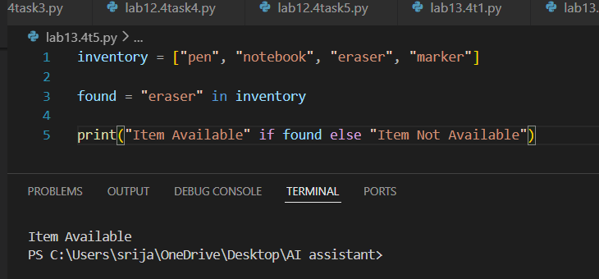
Observation
- The legacy code used a for loop with a flag variable to search for an item.
- The refactored code uses the in operator, which is a simpler and more Pythonic way to check if an element exists in a list.
- This approach reduces code length and improves readability.
- The output remains the same as the original program.

